2012 Final Check-out List for Project Center Student Teams
Project Dept. & Team # ________
You must turn this in NO LATER THAN June 9, 2012

Please have your faculty member sign their initials for the following items:
- ______ (initials) Project Report delivered or mailed to your project sponsor.

- ______ (initials) Project Room is CLEAN
  - Borrowed materials returned to faculty advisor
    - Software: _____________________________
    - Design manuals:_________________________
    - Others:__________________________
  - Prototypes delivered back to sponsor or coordinated with department for storage
  - Room cleaned of food, trash, books, etc

- ______ (initials) Reimbursement requests (Hilary Northcraft E500)

- ______ (initials) Copy card return (Hilary Northcraft E500)

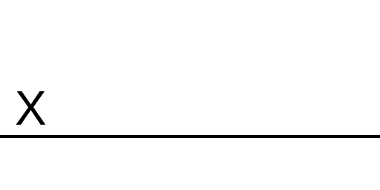
Signed off by all team members and faculty advisor

